x
Amer Masri
~ SAP Technical Project Manager ~
Top-Performing professional, seeking suitable position in Wealth Management, Relationship Management, Senior Brokerage (Global Markets), Capital Markets or Investments
Built distinguished, 14+ years record of progressive achievement across Wealth Management, Relationship Management, Senior Brokerage (global markets), Capital Markets or Investments; currently working as Freelance Fund Manager
UAE: +971XXXXXXX/Jordan: +9627975XXXXX xxxxxxxx@gmail.com

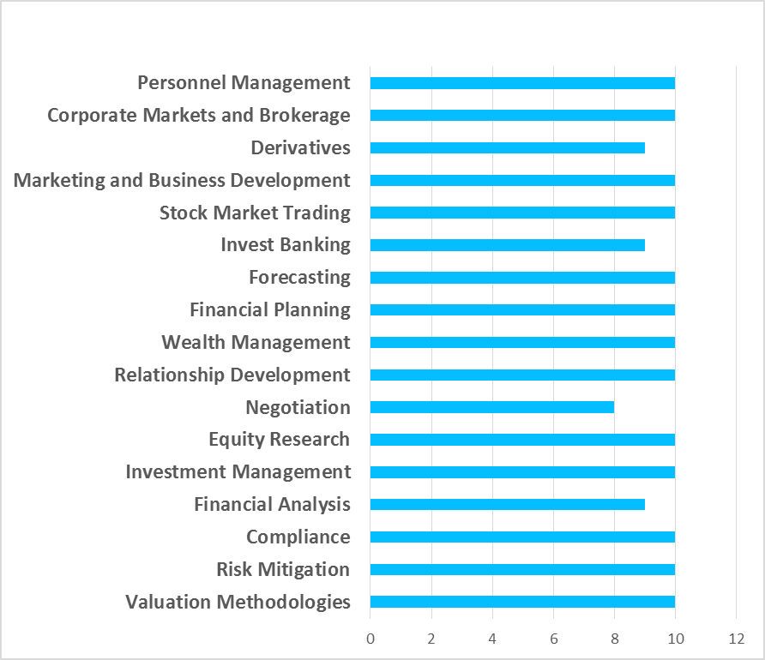

Enterprising and dynamic professional with well-rounded ownership, leadership and decision making skills; significant experience of 14+ years with Financial Institutions. Aiming for bringing in rare level business acumen and record of achievements in the areas of financial management activities like Wealth Management, Investment Management, Forecasting and Portfolio Management. Qualified Finance Professional with comprehensive experience in financial analysis, planning and implementation, investment planning in Capital Markets and wealth management for institutions, small business and individuals. Reputation as someone who “Raises The Bar” for customer service. Possess in-depth knowledge of real estate financial planning, investments, banking, credit solutions etc. Experience of reviewing client portfolios to assess the strategies based on their objectives and risk factor managing wealth for clients and deriving profits from investment. Excellent tendency to keep a track on the market trends and assess data to evaluate the investment opportunities. Familiarity with the laws and regulations related to assets management. Ability to build and retain strong advisor-client relationship. Keep on updating knowledge about the political and social conditions that are affecting financial market.
PROFILE SUMMARY
CORE COMPETENCIES

2002 Bachelors, Finance and Economics from Lebanese American University, Lebanon
Training Undergone:
- Transformational Leadership Workshop, Tanweer Business and Consultancy, Amman, Jordan May 2013
- Technical Analysis for Professionals, Smartline Investment Training Institute, Dubai, UAE, 2013
- Asset Servicing and Custody Reporting by EUROCLEAR, Amman, Jordan, Feb 2013
- Customer Training Workshop by Pershing, Dubai, the UAE, 2009
- Definition of Derivatives by ExecuTrain, Amman, Jordan, 2006
- Private Banking and Wealth Management by EUROMONEY, Amman, Jordan, 2005
- Investment in Financial Securities by Joint efforts, Amman, Jordan, 2004
Professional Memberships:
- Broker’s Certificate, Jordan Securities Commission

ACADEMIC

KEY HIGHLIGHTS
- Analyse financial information obtained from clients to determine strategies for meeting clients' financial objectives.
- Answer clients' questions about the purposes and details of financial plans and strategies.
- Contact clients periodically to determine any changes in their financial status.
- Explain to clients the personal financial advisor's responsibilities and the types of services to be provided.
- Guide clients in the gathering of information, such as bank account records, income tax returns, life and disability insurance records, pension plans, or wills.
- Interview clients to determine their current income, expenses, tax status, financial objectives, risk tolerance, or other information needed to develop a financial plan.
- Meet with clients' other advisors, such as attorneys, accountants, trust officers, or investment bankers, to fully understand clients' financial goals and circumstances.
- Prepare or interpret for client’s information such as investment performance reports, financial document summaries, or income projections.
- Recommend to clients strategies in cash management, investment planning, or other areas to help them achieve their financial goals.
- Working with asset managers to prepare detailed and comprehensive cost sheets, setting up control systems and setting up workflows, timelines and processes in investee companies.
- Ensuring property valuations are done per international standards for the investors.
- Preparing board notes for investee company board meetings and participating in board meetings.
- Review clients' accounts and plans regularly to determine whether life changes, economic changes, environmental concerns, or financial performance indicate a need for plan reassessment.
- Implement financial planning recommendations or refer clients to someone who can assist them with plan implementation.
- Investigate available investment opportunities to determine compatibility with client financial plans.
- Monitor financial market trends to ensure that client plans are responsive.
- Devise debt liquidation plans that include payoff priorities and timelines.
- Manage client portfolios, keeping client plans up-to-date.
- Researching & preparing marketing data for four acquisitions, including history of accounts, competition, pricing schedules, & adjustments.
- Analysing revenues & expenses and recommending corrective actions as required, for any variations compared to Budget / Forecast.
CAREER GRAPH

Presently working as Freelance Fund Manager
Highlights with Awraq Investments, Jordan:
- Directed the corporate financial management team.
- Standardized procedures & recorded step-by-step tasks for future years, reversing a chaotic consolidation process into accuracy & quality.
- Revamped the system of internal controls to ensure effective checks and balances and protect company assets.
- Participated in the signing of major deals that generated revenue and resulted in strong relationships with clients.
- Managed a team of experts dealing with internal and external aspects of client portfolio, e.g., conducted due diligence on new clients & transactions, prepared credit approval memos/packages along with financial analysis.
- Developed strategies for expansion into the MENA market creating significant new revenues and strategic financial plans with department heads.
- Encouraged strong business relationships with financial managers and principals' financial personnel.
- Successfully developed sales and marketing plans within budget constraints. Effectively manage operational risks, clearing and compression functions and participate in process improvement initiatives and system development.

Highlights with AB Invest, Jordan:
- Handled US Equities Desk, promoted the new trading system (Pershing Netexchangepro) locally and regionally)
- Promoted variety of investment products and services and investigated business opportunities.
- Performed profitability analysis on various lines of business, within the corporation, providing the basis for a corporate reorganization.
- Operated successfully on minimal overhead.
- Was responsible for business origination and development across portfolio of private and public-sector clients in Jordan and MENA.

Highlights with Capital Investments, Jordan:
- Worked as a part of a team in helping and assisting clients dealing with US Securities.
- Determined financial impact due to product cost reductions, new product roll out, etc. and prepare periodic forecasts to update management on projected results.
- Setting performance goals, objectives, strategic business plans, policies and procedures for the company.
- Ensured a well-diversified customer base of clients including foreign institutions, Top local and regional banks.
- Promoted to regional responsibilities for business expansion and re-engineering.
- Developed, planned, and implemented processes and programs to upgrade company's image.
- Developed and maintained relationships with strategic national accounts and large corporate clients.
- Created an advisory desk that provides equities trading strategies across the MENA markets to various types of clients; achieved high success rate through the trading ideas generated which highly contributed to the revenue of the department.
- Developed and implemented intra-day and short/long term equity trading strategies to help our clients to achieve good profits.

IT FORTE
- Windows™: (7™, Vista™, XP™)
- Microsoft Office™: (Word™, Excel™ PowerPoint™ Project™)
- Adobe™
- Internet Navigation & E-mail
PERSONAL DOSSIER
Date of Birth: 11th March 1980
Languages Known: Arabic (Native)
Permanent Address: XXXXXXX

